Kalinga University
Faculty of Computer Science
Notes-IV
Course-BCSAIMLCS/BCAAIML
Subject-Deep Learning
Subject Code- BCSAIMLCS502/BCAAIML502 Sem-V

Introduction to Recurrent Neural Networks

Recurrent Neural Networks (RNNs) differ from regular neural networks in how they process information. While standard neural networks pass information in one direction i.e from input to output, RNNs feed information back into the network at each step.
Imagine reading a sentence and you try to predict the next word, you don’t rely only on the current word but also remember the words that came before. RNNs work similarly by “remembering” past information and passing the output from one step as input to the next i.e it considers all the earlier words to choose the most likely next word. This memory of previous steps helps the network understand context and make better predictions.

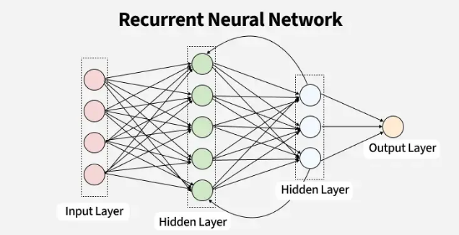

Key Components of RNNs
There are mainly two components of RNNs that we will discuss.

1. Recurrent Neurons
The fundamental processing unit in RNN is a Recurrent Unit. They hold a hidden state that maintains information about previous inputs in a sequence. Recurrent units can "remember" information from prior steps by feeding back their hidden state, allowing them to capture dependencies across time.
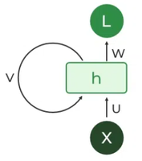Recurrent Neuron

2. RNN Unfolding
RNN unfolding or unrolling is the process of expanding the recurrent structure over time steps. During unfolding each step of the sequence is represented as a separate layer in a series illustrating how information flows across each time step.
This unrolling enables backpropagation through time (BPTT) a learning process where errors are propagated across time steps to adjust the network’s weights enhancing the RNN’s ability to learn dependencies within sequential data.
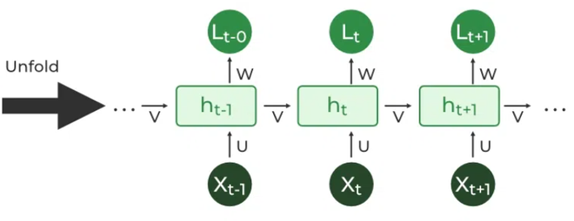RNN Unfolding

Recurrent Neural Network Architecture
RNNs share similarities in input and output structures with other deep learning architectures but differ significantly in how information flows from input to output. Unlike traditional deep neural networks where each dense layer has distinct weight matrices. RNNs use shared weights across time steps, allowing them to remember information over sequences.
In RNNs the hidden state HiHi​​ is calculated for every input XiXi​​ to retain sequential dependencies. The computations follow these core formulas:
1. Hidden State Calculation:
h=σ(U⋅X+W⋅ht−1+B)h=σ(U⋅X+W⋅ht−1​+B)
Here:
- hh represents the current hidden state.
- UU and WW are weight matrices.
- BB is the bias.
2. Output Calculation:
Y=O(V⋅h+C)Y=O(V⋅h+C)
The output YY is calculated by applying OO an activation function to the weighted hidden state where VV and CC represent weights and bias.
3. Overall Function:
Y=f(X,h,W,U,V,B,C)Y=f(X,h,W,U,V,B,C)
This function defines the entire RNN operation where the state matrix SS holds each element sisi​ representing the network's state at each time step ii.
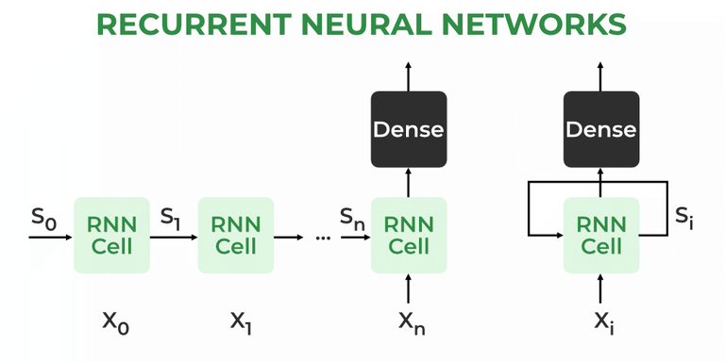Recurrent Neural Architecture

How does RNN work?
At each time step RNNs process units with a fixed activation function. These units have an internal hidden state that acts as memory that retains information from previous time steps. This memory allows the network to store past knowledge and adapt based on new inputs.

Updating the Hidden State in RNNs
The current hidden state htht​​ depends on the previous state ht−1ht−1​​ and the current input xtxt​​ and is calculated using the following relations:
1. State Update:
ht=f(ht−1,xt)ht​=f(ht−1​,xt​)
where:
- htht​​ is the current state
- ht−1ht−1​​ is the previous state
- xtxt​ is the input at the current time step
2. Activation Function Application:
ht=tanh⁡(Whh⋅ht−1+Wxh⋅xt)ht​=tanh(Whh​⋅ht−1​+Wxh​⋅xt​)
Here, WhhWhh​​ is the weight matrix for the recurrent neuron and WxhWxh​​ is the weight matrix for the input neuron.
3. Output Calculation:
yt=Why⋅htyt​=Why​⋅ht​
where ytyt​​ is the output and WhyWhy​​ is the weight at the output layer.
These parameters are updated using backpropagation. However, since RNN works on sequential data here we use an updated backpropagation which is known as backpropagation through time.

Backpropagation Through Time (BPTT) in RNNs
Since RNNs process sequential data Backpropagation Through Time (BPTT) is used to update the network's parameters. The loss function L(θ) depends on the final hidden state h3h3​ and each hidden state relies on preceding ones forming a sequential dependency chain:
h3h3​ depends on depends on h2,h2 depends on h1,…,h1 depends on h0 depends on h2​,h2​ depends on h1​,…,h1​ depends on h0​​.

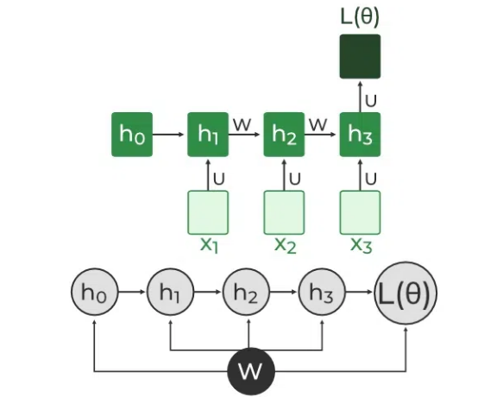

Backpropagation Through Time (BPTT) In RNN
In BPTT, gradients are backpropagated through each time step. This is essential for updating network parameters based on temporal dependencies.
- Simplified Gradient Calculation:
∂L(θ)∂W=∂L(θ)∂h3⋅∂h3∂W∂W∂L(θ)​=∂h3​∂L(θ)​⋅∂W∂h3​​
- Handling Dependencies in Layers: Each hidden state is updated based on its dependencies:
h3=σ(W⋅h2+b)h3​=σ(W⋅h2​+b)
The gradient is then calculated for each state, considering dependencies from previous hidden states.
- Gradient Calculation with Explicit and Implicit Parts: The gradient is broken down into explicit and implicit parts summing up the indirect paths from each hidden state to the weights.
∂h3∂W=∂h3+∂W+∂h3∂h2⋅∂h2+∂W∂W∂h3​​=∂W∂h3+​​+∂h2​∂h3​​⋅∂W∂h2+​​
- Final Gradient Expression: The final derivative of the loss function with respect to the weight matrix W is computed:
∂L(θ)∂W=∂L(θ)∂h3⋅∑k=13∂h3∂hk⋅∂hk∂W∂W∂L(θ)​=∂h3​∂L(θ)​⋅∑k=13​∂hk​∂h3​​⋅∂W∂hk​​
This iterative process is the essence of backpropagation through time.

Types Of Recurrent Neural Networks
There are four types of RNNs based on the number of inputs and outputs in the network:

1. One-to-One RNN
This is the simplest type of neural network architecture where there is a single input and a single output. It is used for straightforward classification tasks such as binary classification where no sequential data is involved.

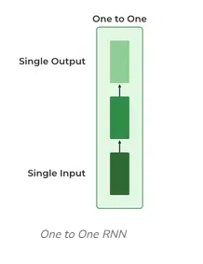

2. One-to-Many RNN
In a One-to-Many RNN the network processes a single input to produce multiple outputs over time. This is useful in tasks where one input triggers a sequence of predictions (outputs). For example in image captioning a single image can be used as input to generate a sequence of words as a caption.

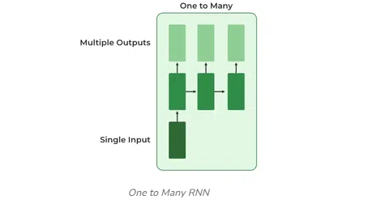

One to Many RNN

3. Many-to-One RNN
The Many-to-One RNN receives a sequence of inputs and generates a single output. This type is useful when the overall context of the input sequence is needed to make one prediction. In sentiment analysis the model receives a sequence of words (like a sentence) and produces a single output like positive, negative or neutral.
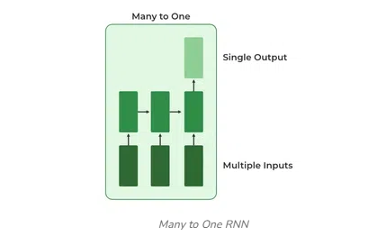
Many to One RNN

4. Many-to-Many RNN
The Many-to-Many RNN type processes a sequence of inputs and generates a sequence of outputs. In language translation task a sequence of words in one language is given as input and a corresponding sequence in another language is generated as output.

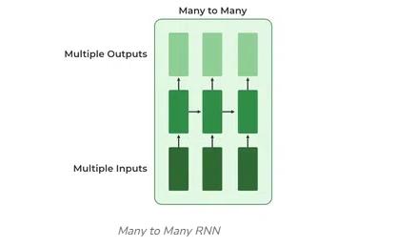

Many to Many RNN

Variants of Recurrent Neural Networks (RNNs)
There are several variations of RNNs, each designed to address specific challenges or optimize for certain tasks:

1. Vanilla RNN
This simplest form of RNN consists of a single hidden layer where weights are shared across time steps. Vanilla RNNs are suitable for learning short-term dependencies but are limited by the vanishing gradient problem, which hampers long-sequence learning.

2. Bidirectional RNNs
Bidirectional RNNs process inputs in both forward and backward directions, capturing both past and future context for each time step. This architecture is ideal for tasks where the entire sequence is available, such as named entity recognition and question answering.

3. Long Short-Term Memory Networks (LSTMs)
Long Short-Term Memory Networks (LSTMs) introduce a memory mechanism to overcome the vanishing gradient problem. Each LSTM cell has three gates:
- Input Gate: Controls how much new information should be added to the cell state.
- Forget Gate: Decides what past information should be discarded.
- Output Gate: Regulates what information should be output at the current step. This selective memory enables LSTMs to handle long-term dependencies, making them ideal for tasks where earlier context is critical.

4. Gated Recurrent Units (GRUs)
Gated Recurrent Units (GRUs) simplify LSTMs by combining the input and forget gates into a single update gate and streamlining the output mechanism. This design is computationally efficient, often performing similarly to LSTMs and is useful in tasks where simplicity and faster training are beneficial.

How RNN Differs from Feedforward Neural Networks?
Feedforward Neural Networks (FNNs) process data in one direction from input to output without retaining information from previous inputs. This makes them suitable for tasks with independent inputs like image classification. However FNNs struggle with sequential data since they lack memory.
Recurrent Neural Networks (RNNs) solve this by incorporating loops that allow information from previous steps to be fed back into the network. This feedback enables RNNs to remember prior inputs making them ideal for tasks where context is important.
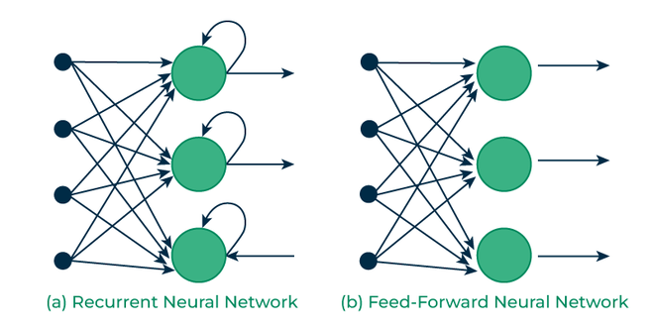Recurrent Vs Feedforward networks

Implementing a Text Generator Using Recurrent Neural Networks (RNNs)
In this section, we create a character-based text generator using Recurrent Neural Network (RNN) in TensorFlow and Keras. We'll implement an RNN that learns patterns from a text sequence to generate new text character-by-character.

1. Importing Necessary Libraries
We start by importing essential libraries for data handling and building the neural network.

import numpy as np
import tensorflow as tf
from tensorflow.keras.models import Sequential
from tensorflow.keras.layers import SimpleRNN, Dense

2. Defining the Input Text and Prepare Character Set
We define the input text and identify unique characters in the text which we’ll encode for our model.
text = "This is GeeksforGeeks a software training institute"
chars = sorted(list(set(text)))
char_to_index = {char: i for i, char in enumerate(chars)}
index_to_char = {i: char for i, char in enumerate(chars)}

3. Creating Sequences and Labels
To train the RNN, we need sequences of fixed length (seq_length) and the character following each sequence as the label.
seq_length = 3
sequences = []
labels = []

for i in range(len(text) - seq_length):
seq = text[i:i + seq_length]
label = text[i + seq_length]
sequences.append([char_to_index[char] for char in seq])
labels.append(char_to_index[label])

X = np.array(sequences)
y = np.array(labels)

4. Converting Sequences and Labels to One-Hot Encoding
For training we convert X and y into one-hot encoded tensors.
X_one_hot = tf.one_hot(X, len(chars))
y_one_hot = tf.one_hot(y, len(chars))

5. Building the RNN Model
We create a simple RNN model with a hidden layer of 50 units and a Dense output layer with softmax activation.
model = Sequential()
model.add(SimpleRNN(50, input_shape=(seq_length, len(chars)), activation='relu'))
model.add(Dense(len(chars), activation='softmax'))

6. Compiling and Training the Model
We compile the model using the categorical_crossentropy loss and train it for 100 epochs.
model.compile(optimizer='adam', loss='categorical_crossentropy', metrics=['accuracy'])
model.fit(X_one_hot, y_one_hot, epochs=100)
Output:
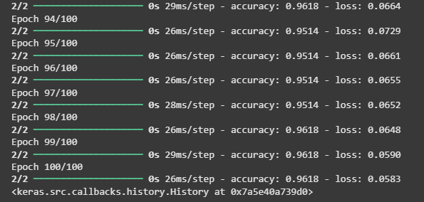Training the RNN model

7. Generating New Text Using the Trained Model
After training we use a starting sequence to generate new text character by character.
start_seq = "This is G"
generated_text = start_seq

for i in range(50):
x = np.array([[char_to_index[char] for char in generated_text[-seq_length:]]])
x_one_hot = tf.one_hot(x, len(chars))
prediction = model.predict(x_one_hot)
next_index = np.argmax(prediction)
next_char = index_to_char[next_index]
generated_text += next_char

print("Generated Text:")
print(generated_text)
Output:
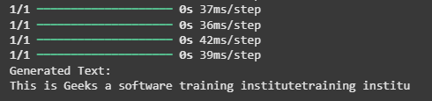Predicting the next word

Advantages of Recurrent Neural Networks
- Sequential Memory: RNNs retain information from previous inputs making them ideal for time-series predictions where past data is crucial.
- Enhanced Pixel Neighborhoods: RNNs can be combined with convolutional layers to capture extended pixel neighborhoods improving performance in image and video data processing.

Limitations of Recurrent Neural Networks (RNNs)
While RNNs excel at handling sequential data they face two main training challenges i.e vanishing gradient and exploding gradient problem:
- Vanishing Gradient: During backpropagation gradients diminish as they pass through each time step leading to minimal weight updates. This limits the RNN’s ability to learn long-term dependencies which is crucial for tasks like language translation.
- Exploding Gradient: Sometimes gradients grow uncontrollably causing excessively large weight updates that de-stabilize training.
These challenges can hinder the performance of standard RNNs on complex, long-sequence tasks.

Applications of Recurrent Neural Networks
RNNs are used in various applications where data is sequential or time-based:
- Time-Series Prediction: RNNs excel in forecasting tasks, such as stock market predictions and weather forecasting.
- Natural Language Processing (NLP): RNNs are fundamental in NLP tasks like language modeling, sentiment analysis and machine translation.
- Speech Recognition: RNNs capture temporal patterns in speech data, aiding in speech-to-text and other audio-related applications.
- Image and Video Processing: When combined with convolutional layers, RNNs help analyze video sequences, facial expressions and gesture recognition.

What is a Memory Cell?
The memory cell is the core component of an RNN. It is responsible for storing and passing information from one step in the sequence to the next.
In simpler terms, the memory cell works like a temporary memory that remembers what happened in previous steps and uses this memory to make decisions in the current step. This allows the RNN to consider both the current input and the previous context.

🔸 How the Memory Works
At each point in the sequence, the memory cell:
- Receives the current input (like a word in a sentence or a value in a time series)
- Takes in information from the previous step (this includes what it had already learned or remembered from earlier inputs)
- Processes both pieces of information together
- Updates its own memory so it is ready for the next input in the sequence
- Produces an output based on the updated memory and current input
This process repeats at each step in the sequence, enabling the RNN to make decisions that depend on the entire input history.

🔸 Example Analogy
Think of the memory cell as a human trying to understand a sentence word by word. The person listens to one word at a time but keeps track of the whole sentence in their mind. When they hear the next word, they don’t just consider it alone — they also think about the words they have already heard. Similarly, an RNN memory cell remembers previous inputs and combines them with the current input to understand the full meaning.

🔸 Advantages of RNN Memory Cells
- Sequence Understanding: They help in learning patterns over time, such as predicting the next word in a sentence or forecasting the next stock price.
- Context Awareness: The memory cell maintains context, which is crucial in language and speech where meaning depends on earlier words or sounds.
- Parameter Sharing: The same logic and parameters are used for each step in the sequence, making the network efficient and capable of handling sequences of different lengths.
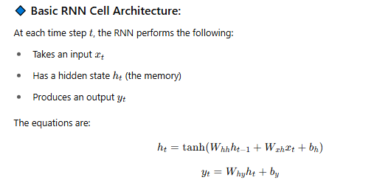
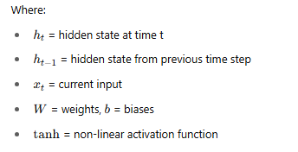

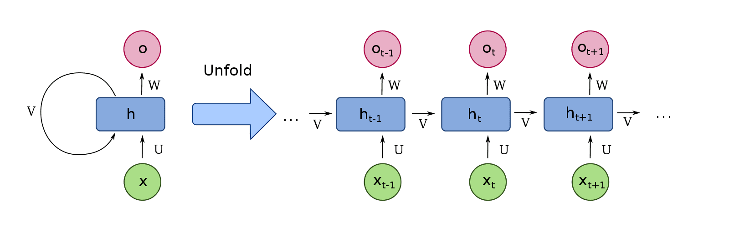

🔸 Limitations of Basic Memory Cells in RNN
Despite their usefulness, basic memory cells have several drawbacks:
- Short-Term Memory: They often forget older information quickly. This is a problem in long sequences where earlier inputs are important for understanding later ones.
- Vanishing Gradient Problem: During training, the importance of earlier steps may become extremely small, making it hard for the network to learn long-term dependencies.
- Difficulty in Learning Long Contexts: If a sequence has long gaps between relevant information, the basic memory cell struggles to connect them effectively.

🔸 Solutions to RNN Limitations
To overcome these limitations, more advanced memory cells were developed:
- LSTM (Long Short-Term Memory): This architecture includes special structures called gates that decide what to remember and what to forget. It significantly improves the ability to remember long-term information.
- GRU (Gated Recurrent Unit): Similar to LSTM but with a simpler design. It is also effective in learning long-term patterns.
These advanced models allow RNNs to handle longer sequences and more complex patterns with greater accuracy.

Applications of RNN Memory Cells
- Natural Language Processing: Understanding language, generating text, translation, summarization.
- Speech Recognition: Converting speech to text, voice-controlled systems.
- Time Series Prediction: Forecasting future values based on historical data.
- Music and Sound Generation: Creating melodies or sound patterns.
- Video Frame Prediction: Predicting future frames in a video sequence.

Recurrent Neural Networks (RNNs) for Sequence Processing

In the world of deep learning, sequence data plays a pivotal role in various applications, such as natural language processing (NLP) and time series forecasting. This blog will explore the workings of Recurrent Neural Networks (RNNs), a class of neural networks well-suited for sequence processing, and how they are leveraged in tasks like language modeling, sentiment analysis, and more. We will also cover their strengths and limitations, particularly in comparison with traditional feedforward networks.
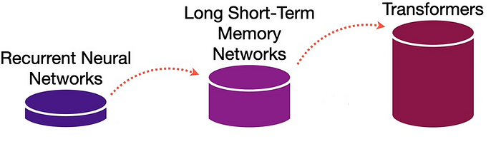

What is Sequential Data?
Sequential data consists of a series of elements arranged in a specific order where the sequence itself is crucial for understanding the data. Two common types of sequential data are:
- Natural Language: Language is inherently sequential. The meaning of a sentence depends on the order of words. For example, the sentences “The cat chased the mouse” and “The mouse chased the cat” have the same words, but swapping their order changes the meaning entirely.
- Time Series: A time series is a sequence of data points indexed in time order. It has natural temporal ordering, which means that events earlier in the sequence influence those that come later. Predicting stock prices or weather patterns are classic examples of time series tasks.
Why Feedforward Neural Networks Fall Short: Feedforward neural networks (FFNNs) are designed for fixed-dimensional input-output tasks like image classification. They process inputs in one direction, from the input layer to the output layer, without any cyclic connections or memory of prior inputs. However, this structure prevents FFNNs from handling sequential data efficiently because they don’t account for the order or dependencies between elements.
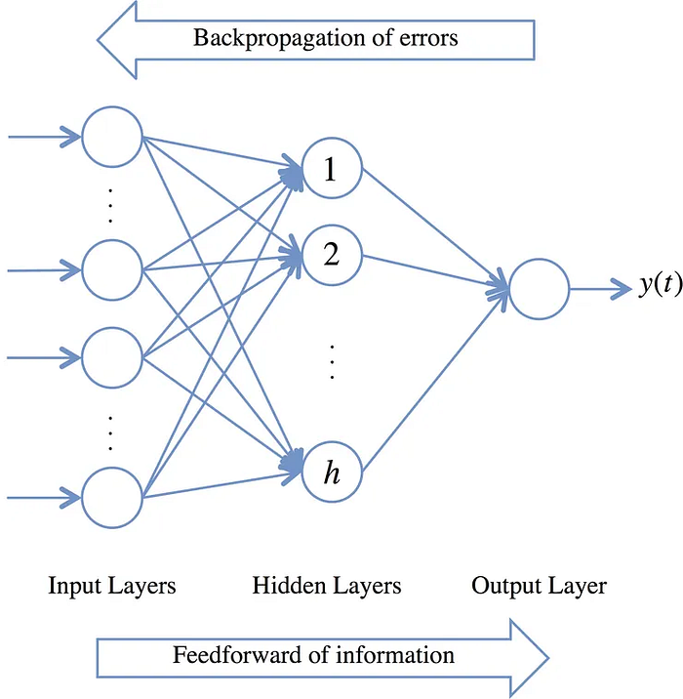
Neural networks involve illustrating interconnected nodes organized in layers, showcasing input, hidden, and output layers with specific connections. ‘Feedforward neural networks’ are trained using the backpropagation method.
Enter Recurrent Neural Networks (RNNs): Recurrent Neural Networks (RNNs) are specifically designed to handle sequential data. Unlike FFNNs, RNNs have feedback loops that allow information from previous inputs to influence the current output. This internal state, known as the hidden state, stores memory from past inputs, giving RNNs a form of short-term memory. This architecture allows RNNs to process sequences of varying lengths, such as sentences or time series data, where the order of elements is crucial. At each time step 𝑡, the hidden state ℎ 𝑡​ is updated based on both the current input 𝑥 𝑡​ and the previous hidden state ℎ 𝑡 − 1, capturing dependencies from earlier in the sequence.
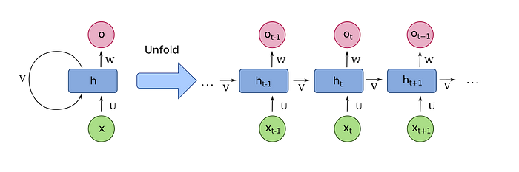
A ‘basic recurrent neural network’ connects the outputs of all artificial neurons as inputs to the same nodes. The illustration shows different steps unfolded in time of the same ‘fully recurrent neural network’, and these are not “layers” of an ‘artificial neural network’.

RNN Architectures for Sequence Processing
RNNs are flexible and can be structured into different input-output architectures depending on the task:
- Vector-to-Sequence (Vec2Seq): Used in tasks like image captioning or text generation, where a fixed input is mapped to a sequence of outputs.
- Sequence-to-Vector (Seq2Vec): Common in sentiment analysis and text classification, where a sequence (like a sentence) is mapped to a fixed output.
- Sequence-to-Sequence (Seq2Seq): Used in tasks like machine translation and time series forecasting, where both the input and output are sequences.
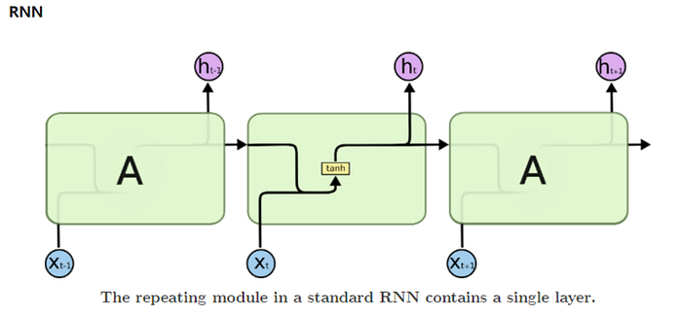

Challenges with Basic RNNs
While RNNs are powerful, basic (or vanilla) RNNs face several limitations:
- Vanishing and Exploding Gradients: When training RNNs on long sequences, the gradients used for backpropagation can either become too small (vanishing gradients) or too large (exploding gradients), preventing the network from learning long-term dependencies. This issue is particularly problematic for tasks requiring memory of earlier sequence elements.
- Limited Context Awareness: Basic RNNs only consider past information when predicting future outputs, meaning they struggle to capture dependencies from future tokens. For example, understanding a word in a sentence may require knowledge of the words that come after it, as well as those that come before.
- Slow Training Times: Processing sequentially, one element at a time, results in slow training times, especially when dealing with long sequences.

Advanced RNN Architectures
Several modifications to the basic RNN architecture have been introduced to address these challenges:
- Bidirectional RNNs (BiRNNs): These networks process sequences in both forward and backward directions, capturing dependencies from both past and future tokens. This structure is especially useful in NLP tasks like named entity recognition (NER) and part-of-speech (PoS) tagging, where the context surrounding a word is vital.
- Gated RNNs: Long Short-Term Memory (LSTM) and Gated Recurrent Unit (GRU) networks are designed to solve the vanishing gradient problem. Both LSTMs and GRUs introduce gates (such as forget, input, and output gates in LSTMs) that control the flow of information, allowing the network to retain important information over long sequences while discarding irrelevant data.
- Attention Mechanisms: In complex tasks like machine translation, attention mechanisms help the model focus on specific parts of the input sequence when generating the output. This allows the network to capture long-range dependencies and improves performance on tasks involving lengthy sequences.
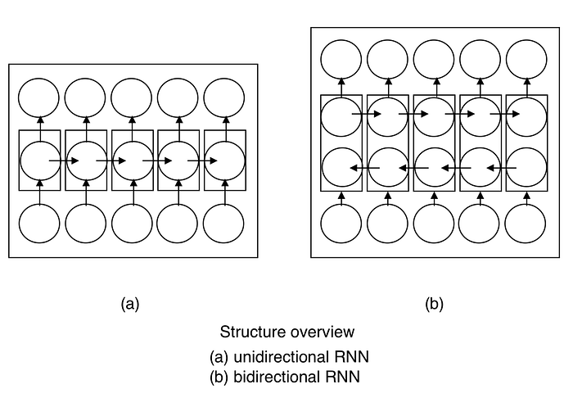
Backpropagation Through Time (BPTT): Training RNNs involves a special form of backpropagation known as Backpropagation Through Time (BPTT). In this process, the RNN is “unfolded” in time, and gradients are computed for each time step. BPTT calculates the gradient of the loss with respect to all weights in the network. However, BPTT struggles with very long sequences due to vanishing or exploding gradients.
Despite their power, RNNs have several limitations, such as slow sequential processing and difficulty in parallelizing computation. The Transformer architecture, introduced in 2017, has emerged as a popular alternative, offering faster training times and better performance on many sequence tasks. Transformers use self-attention mechanisms, allowing them to process all words in a sequence simultaneously, capturing long-range dependencies without the need for recurrent connections.
Recurrent Neural Networks represent a major step forward in processing sequential data, enabling advancements in natural language processing, time series forecasting, and more. While RNNs have their challenges, including the vanishing gradient problem and slow training, they have been supplemented by advanced architectures like LSTMs, GRUs, and attention-based models. Looking ahead, Transformers continue to push the boundaries of sequence processing, offering new possibilities for faster and more efficient models.

Word2Vec in Recurrent Neural Networks (RNN)

🔸 Introduction
In Natural Language Processing (NLP), we need to convert words into numbers so that computers can understand and work with them. But simply assigning a unique number to each word is not enough — this approach doesn’t capture the meaning or context of the words.
Word2Vec is a technique that helps solve this problem. It turns words into vectors (ordered lists of numbers) in such a way that words with similar meanings are close together in this numerical space.

Word2Vec is a technique used in Natural Language Processing to convert words into numerical representations called word embeddings. These embeddings are dense vectors that capture the meaning and context of words based on how they are used in a large corpus of text. Recurrent Neural Networks, or RNNs, are a type of neural network specifically designed to work with sequential data such as sentences or time series. Since RNNs cannot directly understand raw text, words must first be converted into numerical format before being processed.
Traditional methods like one-hot encoding represent each word as a binary vector, where only one position is set to one and the rest are zeros. However, one-hot encoding does not capture any relationship between words. For example, the words "cat" and "dog" would be represented as completely unrelated even though they are semantically similar. This is a major limitation when trying to understand language. Word2Vec solves this problem by generating dense vectors where words with similar meanings are placed close to each other in vector space.
Word2Vec works by training a shallow neural network on a large text corpus using one of two models: Continuous Bag of Words (CBOW) or Skip-Gram. In the CBOW model, the algorithm tries to predict a target word using the surrounding context words. In the Skip-Gram model, the algorithm does the opposite: it uses a single word to predict surrounding context words. Both approaches help the model learn how words appear in relation to each other, and over time it builds a meaningful mapping between words and vectors.
Once a Word2Vec model is trained, it can be used to convert each word in a sentence into its corresponding vector. These vectors can then be fed into an RNN as input. The RNN processes these word vectors one at a time, maintaining an internal memory of previous words in the sequence through its hidden state. Because the input vectors from Word2Vec already contain semantic information, the RNN is better equipped to understand the meaning and context of the sentence. This improves the RNN’s performance in tasks like text generation, sentiment analysis, and machine translation.
The integration of Word2Vec and RNN provides several advantages. First, it allows the model to understand word similarity, such as recognizing that "king" and "queen" are related. Second, it reduces the size of the input data because the vectors are dense and compact. Third, it helps the RNN learn more quickly and accurately because it receives meaningful input representations rather than sparse and meaningless one-hot vectors. Finally, pre-trained Word2Vec models can be used across different projects, saving time and computational resources.

🔸 Why Do We Need Word2Vec in RNNs?
Recurrent Neural Networks are commonly used for tasks involving sequences of text — such as text generation, translation, or sentiment analysis. But RNNs can’t directly work with raw words. They need numeric inputs.
- If we use one-hot encoding (a basic method), each word is represented as a large sparse vector where only one position is "on." But one-hot vectors do not show any relationship between words.
- For example, the words “king” and “queen” would be just as unrelated as “king” and “banana.”
This is where Word2Vec helps — it provides dense vector representations of words that preserve meaning and context.
🔸 What is Word2Vec?
Word2Vec is a technique developed by researchers at Google. It is a shallow neural network model that learns to represent words as vectors based on their context in sentences.
It creates a word embedding, which is a mapping of words to vectors in a continuous vector space. In this space:
- Words with similar meanings are located closer together.
- The direction and distance between word vectors can represent relationships. For example, “man” to “king” is similar to “woman” to “queen.”

🔸 How Word2Vec Works
Word2Vec works using two basic training models:
- Continuous Bag of Words (CBOW):
  - Predicts a word based on its surrounding words.
  - For example, if the sentence is “the cat sits on the __,” it tries to guess the missing word "mat."
- Skip-Gram:
  - Predicts the surrounding words based on a target word.
  - If the target word is “school,” it tries to predict the nearby words like “go,” “children,” or “study.”
These models do not use deep layers; they are fast and efficient and can be trained on large datasets to capture rich word meanings.

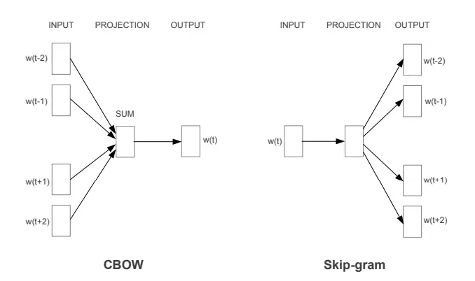

🔸 Word2Vec and RNN Together
Here’s how Word2Vec is typically used with RNNs:
- Word2Vec First:
  - A dataset of text is used to train a Word2Vec model.
  - Each word is transformed into a dense vector (embedding).
- Use in RNN:
  - The RNN takes these word vectors as input instead of one-hot vectors.
  - This allows the RNN to understand the semantic meaning of the words.
  - As a result, the RNN performs better in understanding language patterns, generating text, and making predictions.

🔸 Benefits of Using Word2Vec in RNN
- Captures Meaning: Words with similar usage or meaning are represented by similar vectors.
- Reduces Input Size: Word2Vec produces fixed-size dense vectors, reducing the complexity of the input.
- Improves Performance: Since the input vectors already contain semantic information, the RNN learns better and faster.
- Transferable: Pre-trained Word2Vec models (like Google News vectors) can be used in different tasks, saving training time.

🔸 Applications of Word2Vec + RNN
- Text Generation: Creating meaningful text sequences.
- Language Translation: Translating sentences from one language to another.
- Sentiment Analysis: Understanding emotions or opinions in text.
- Chatbots and Virtual Assistants: Understanding and generating user responses.
- Speech Recognition: Converting spoken words into meaningful text.
- In applications, combining Word2Vec with RNN is common in natural language tasks such as chatbots, virtual assistants, text summarization, and speech recognition. The word embeddings make it possible for RNNs to capture the deeper relationships and patterns in language, leading to more intelligent and context-aware predictions.
- In summary, Word2Vec is an essential technique for converting words into useful numerical formats. When used with RNNs, it significantly enhances the ability of the model to process and understand sequential language data. This combination has become a standard approach in many modern NLP systems.
Word2Vec transforms words into vectors using a shallow neural network. The idea is to learn vector representations (embeddings) for each word such that words appearing in similar contexts have similar vectors.
Let’s assume a vocabulary of size V and an embedding dimension of N.
Each word is represented as a one-hot encoded vector of size V. If a word is at index i in the vocabulary, then its one-hot vector x has all zeros except a 1 at position i.
Now, Word2Vec aims to learn two matrices:
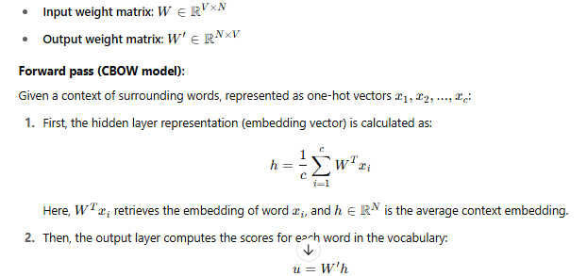
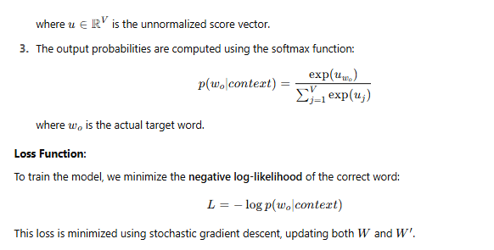
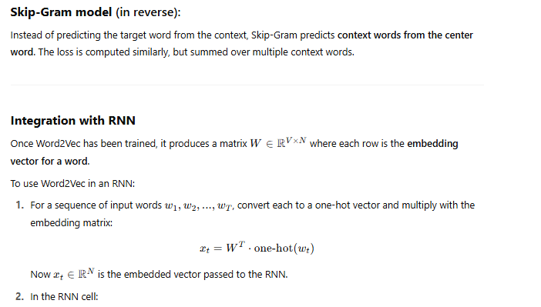
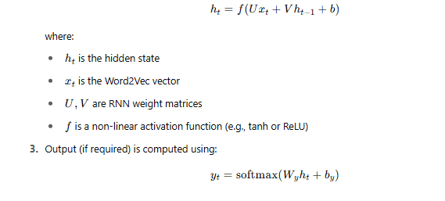
• Word2Vec learns embeddings by optimizing a shallow network using softmax and cross-entropy loss.
• The embedding matrix WWW from Word2Vec replaces one-hot input in RNNs with dense vector representations.
• These embeddings serve as more meaningful inputs for RNNs, enabling them to learn temporal patterns in natural language more effectively.

What is LSTM - Long Short Term Memory?

Long Short-Term Memory (LSTM) is an enhanced version of the Recurrent Neural Network (RNN) designed by Hochreiter and Schmidhuber. LSTMs can capture long-term dependencies in sequential data making them ideal for tasks like language translation, speech recognition and time series forecasting.
Unlike traditional RNNs which use a single hidden state passed through time LSTMs introduce a memory cell that holds information over extended periods addressing the challenge of learning long-term dependencies.

1 / 3

Problem with Long-Term Dependencies in RNN
Recurrent Neural Networks (RNNs) are designed to handle sequential data by maintaining a hidden state that captures information from previous time steps. However they often face challenges in learning long-term dependencies where information from distant time steps becomes crucial for making accurate predictions for current state. This problem is known as the vanishing gradient or exploding gradient problem.
- Vanishing Gradient: When training a model over time, the gradients which help the model learn can shrink as they pass through many steps. This makes it hard for the model to learn long-term patterns since earlier information becomes almost irrelevant.
- Exploding Gradient: Sometimes gradients can grow too large causing instability. This makes it difficult for the model to learn properly as the updates to the model become erratic and unpredictable.
Both of these issues make it challenging for standard RNNs to effectively capture long-term dependencies in sequential data.

LSTM Architecture
LSTM architectures involves the memory cell which is controlled by three gates:
- Input gate: Controls what information is added to the memory cell.
- Forget gate: Determines what information is removed from the memory cell.
- Output gate: Controls what information is output from the memory cell.
This allows LSTM networks to selectively retain or discard information as it flows through the network which allows them to learn long-term dependencies. The network has a hidden state which is like its short-term memory. This memory is updated using the current input, the previous hidden state and the current state of the memory cell.

Working of LSTM
LSTM architecture has a chain structure that contains four neural networks and different memory blocks called cells.

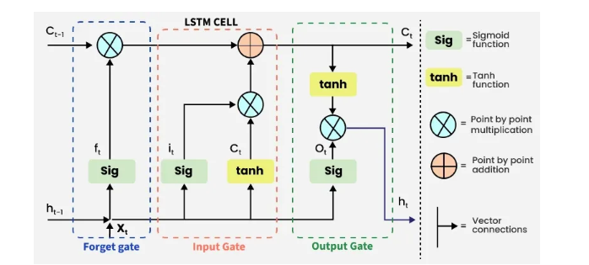

LSTM Model
Information is retained by the cells and the memory manipulations are done by the gates. There are three gates -

1. Forget Gate
The information that is no longer useful in the cell state is removed with the forget gate. Two inputs xtxt​ (input at the particular time) and ht−1ht−1​ (previous cell output) are fed to the gate and multiplied with weight matrices followed by the addition of bias. The resultant is passed through an activation function which gives a binary output. If for a particular cell state the output is 0, the piece of information is forgotten and for output 1, the information is retained for future use.
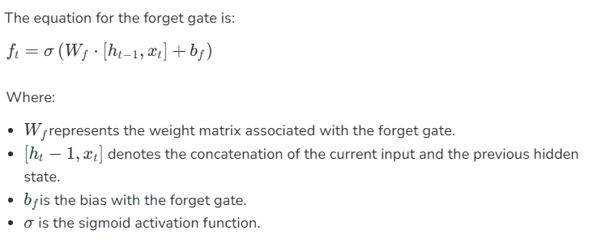

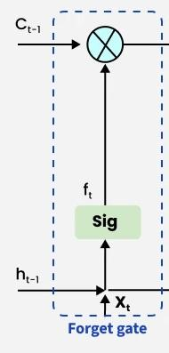Forget Gate

2. Input gate
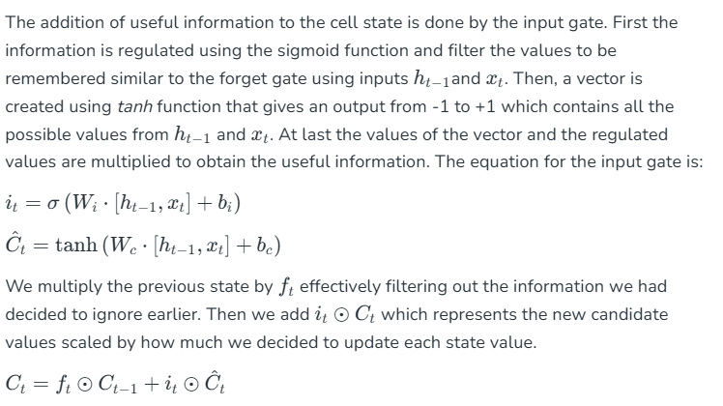where
- ⊙denotes element-wise multiplication
- tanh is activation function
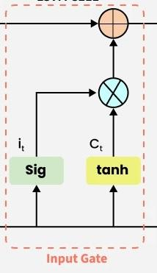Input Gate

3. Output gate
The task of extracting useful information from the current cell state to be presented as output is done by the output gate. First, a vector is generated by applying tanh function on the cell. Then, the information is regulated using the sigmoid function and filter by the values to be remembered using inputsht−1ht−1​and xtxt​. At last the values of the vector and the regulated values are multiplied to be sent as an output and input to the next cell. The
equation for the output gate is:
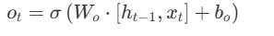

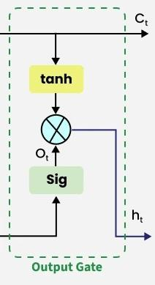Output Gate

Applications of LSTM
Some of the famous applications of LSTM includes:
- Language Modeling: Used in tasks like language modeling, machine translation and text summarization. These networks learn the dependencies between words in a sentence to generate coherent and grammatically correct sentences.
- Speech Recognition: Used in transcribing speech to text and recognizing spoken commands. By learning speech patterns they can match spoken words to corresponding text.
- Time Series Forecasting: Used for predicting stock prices, weather and energy consumption. They learn patterns in time series data to predict future events.
- Anomaly Detection: Used for detecting fraud or network intrusions. These networks can identify patterns in data that deviate drastically and flag them as potential anomalies.
- Recommender Systems: In recommendation tasks like suggesting movies, music and books. They learn user behavior patterns to provide personalized suggestions.
- Video Analysis: Applied in tasks such as object detection, activity recognition and action classification. When combined with Convolutional Neural Networks (CNNs) they help analyze video data and extract useful information.

What is memory-augmented neural networks (manns)?
Memory-augmented neural networks, often abbreviated as MANNs, are a class of artificial neural networks that incorporate an external memory component, enabling them to address complex learning tasks that traditional neural networks may struggle to handle. Unlike conventional neural networks, MANNs can effectively retain and access information from a memory matrix, thus expanding their capacity to process and comprehend extensive datasets. This unique architecture allows MANNs to excel in tasks requiring associative recall and rapid adaptation, making them ideal for a wide array of applications in the realm of artificial intelligence.

Background/history of memory-augmented neural networks (manns)

The Origin of Memory-Augmented Neural Networks (MANNs)
The concept of memory-augmented neural networks traces its origins to the imperative need for AI systems capable of simulating human-like memory and cognitive functions. The pivotal work of researchers in cognitive science and computer science paved the way for the development of memory-augmented neural networks, aiming to imbue AI models with the ability to retain information over time and access it when needed. The inception of MANNs marked a paradigm shift in the field of AI, opening up new possibilities for mimicking human memory processes in machines and enabling more sophisticated problem-solving approaches.

The Evolution of Memory-Augmented Neural Networks (MANNs)
The evolution of memory-augmented neural networks has been characterized by significant advancements in neural network architectures, data representation, and memory management techniques within AI systems. Over time, researchers and practitioners have continually refined MANNs, enhancing their memory access mechanisms, improving scalability, and optimizing their performance across diverse domains. As the AI community delves deeper into the potential of MANNs, the evolution of these networks showcases a trajectory of progress, innovation, and a deeper understanding of memory-augmented systems.
Use Lark Base AI workflows to unleash your team productivity.

Significance of memory-augmented neural networks (manns)
Memory-augmented neural networks hold profound significance in the domain of artificial intelligence due to their unparalleled ability to simulate human memory and cognitive reasoning within computational models. The incorporation of external memory components elevates the learning and inference capabilities of neural networks, enabling them to tackle complex sequential data, inferential reasoning, and knowledge retention tasks with remarkable efficiency. Furthermore, the significance of MANNs stems from their potential to enhance AI systems across industries, foster human-AI collaboration, and lay the foundation for the next generation of intelligent, adaptive systems.

How memory-augmented neural networks (manns) work

Core Characteristics of Memory-Augmented Neural Networks (MANNs)
Memory-augmented neural networks leverage the fundamental principle of storing and retrieving information from external memory, which sets them apart from traditional neural network architectures. The core characteristics of MANNs include:
- Memory Matrix: MANNs possess a structured memory bank that facilitates the storage and retrieval of information, akin to the human memory process. This enables them to effectively learn from past experiences, make informed decisions, and retain knowledge for future use.
- Dynamic Access Mechanism: MANNs employ adaptive mechanisms to access and update the information stored in the memory matrix, allowing them to prioritize relevant data and adapt to evolving patterns within the input data stream.
- Enhanced Learning Capabilities: The integration of external memory endows MANNs with enhanced learning and generalization abilities, enabling them to handle tasks requiring continual adaptation, context-based inference, and associative recall.
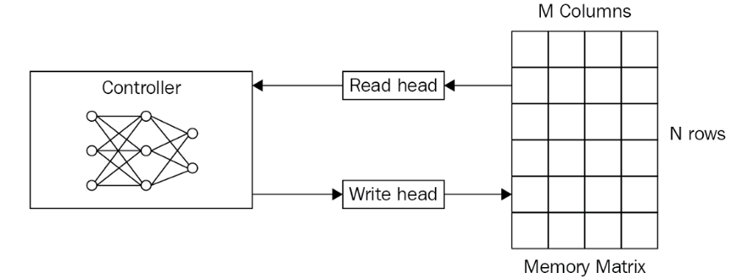
Memory-Augmented Neural Networks (MANNs) are a sophisticated class of artificial neural networks that integrate an external memory component. This design allows MANNs to perform tasks that require the manipulation and retention of information over longer periods than traditional neural networks can handle. They are particularly adept at tasks involving complex sequences, long-term dependencies, and associative recall.
MANNs are inspired by the way humans use working memory to temporarily store and manipulate information. By augmenting neural networks with memory, MANNs can maintain a state or remember past events, which is crucial for sequential tasks such as language processing, time series prediction, and algorithmic problem-solving.

How do MANNs work?
MANNs typically consist of a controller (usually a recurrent neural network or RNN) and an external memory matrix. The controller interacts with the memory using read and write operations, which are learned during training. These operations enable the network to store information in memory and retrieve it when necessary.
The controller decides what to store, when to store it, and what to retrieve from memory based on the current input and the task at hand. This process is often guided by attention mechanisms that allow the network to focus on specific parts of the memory.

What are the key features of MANNs?
Key features of Memory-Augmented Neural Networks include:
- External Memory — Unlike traditional neural networks, MANNs use an external memory component that can store a large amount of information separately from the network's parameters.
- Dynamic Read/Write Operations — MANNs can dynamically read from and write to the memory during the processing of input sequences, allowing for complex data manipulation.
- Attention Mechanisms — Many MANNs utilize attention mechanisms to selectively focus on relevant parts of the memory, improving the efficiency and accuracy of memory retrieval.
- Long-Term Dependencies — MANNs are particularly effective at handling long-term dependencies within data, which is a challenge for standard RNNs.

What are the benefits of MANNs?
The benefits of Memory-Augmented Neural Networks include:
- Enhanced Capacity for Sequence Modeling — MANNs can handle longer sequences with more complex structures than traditional RNNs, making them suitable for tasks like language modeling and machine translation.
- Improved Generalization — By separating the memory from the parameters of the neural network, MANNs can generalize better to new tasks without the need for extensive retraining.
- Flexible Data Storage and Retrieval — The ability to store and retrieve information on demand makes MANNs versatile for a range of applications, from question-answering systems to reinforcement learning.

What are the limitations of MANNs?
Despite their advantages, Memory-Augmented Neural Networks also have limitations:
- Complexity and Computation Cost — The addition of an external memory component increases the complexity of the network, which can lead to higher computational costs during training and inference.
- Training Challenges — Learning the optimal read and write operations is a non-trivial task that can make training MANNs more challenging compared to traditional neural networks.
- Scalability — As the size of the memory grows, it can become difficult to manage and scale MANNs efficiently, especially for very large datasets or tasks.

What are the applications of MANNs?
Memory-Augmented Neural Networks have been applied to a variety of tasks, including:
- Natural Language Processing — MANNs have been used for language modeling, machine translation, and question-answering, where the ability to remember context and relationships between words is crucial.
- Reinforcement Learning — In reinforcement learning, MANNs can help agents remember past states and actions, which is beneficial for tasks that require long-term planning.
- One-shot Learning — MANNs can be effective for one-shot learning scenarios, where a model must generalize from a single example, due to their ability to quickly store and retrieve information.
- Algorithmic Tasks — MANNs can learn to execute algorithmic procedures, such as sorting or searching, by leveraging their memory to store intermediate results and control the flow of the algorithm.

What is a Neural Turing Machine?
A Neural Turing Machine (NTM) is a type of artificial neural network that combines traditional neural networks with memory capabilities akin to those of a Turing machine. The NTM architecture was introduced by Alex Graves, Greg Wayne, and Ivo Danihelka of DeepMind Technologies in their 2014 paper "Neural Turing Machines." The goal of NTMs is to enhance the ability of neural networks to store, manipulate, and retrieve data, thereby enabling them to solve complex tasks that require logical reasoning and algorithmic-like processing.

Understanding Neural Turing Machines
Neural Turing Machines are designed to overcome the limitations of standard neural networks, which excel at pattern recognition but struggle with tasks that require data storage and manipulation over extended time periods. NTMs achieve this by incorporating an external memory matrix that the network can read from and write to, effectively giving the network a "memory" to store information beyond the transient activations of its neurons.
The NTM operates with a controller, typically a recurrent neural network, that interacts with the memory matrix through a series of differentiable read and write operations. This design allows the NTM to learn how to use its memory to perform tasks that require maintaining and updating state information over time.

Components of a Neural Turing Machine
The key components of an NTM include:
- Controller: The central neural network that learns to read from and write to the memory matrix, akin to the processor in a computer.
- Memory Matrix: An array where data is stored, which can be accessed and modified by the controller.
- Read Heads: Components that allow the controller to retrieve information from the memory matrix.
- Write Heads: Components that enable the controller to store or update information in the memory matrix.
- Attention Mechanisms: Soft addressing systems that determine the focus of the read and write heads on the memory matrix, allowing the NTM to access memory content based on content or location.

How Neural Turing Machines Work

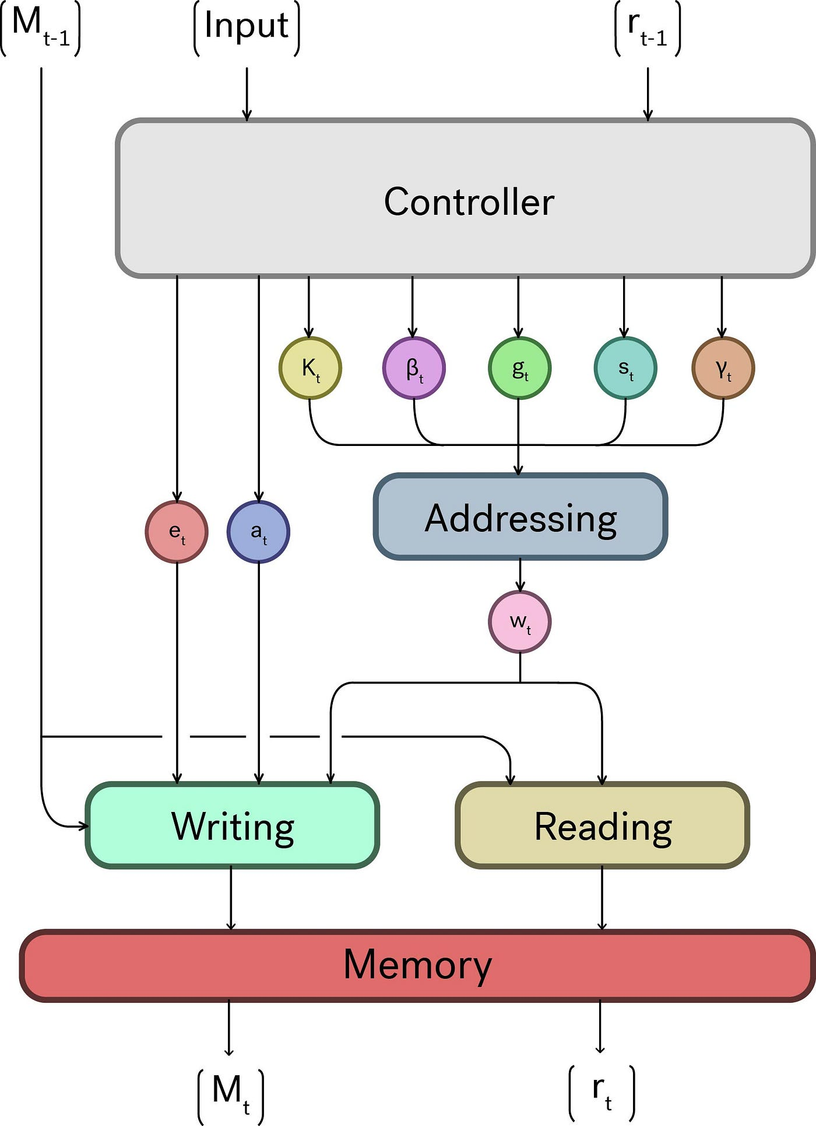
Neural Turing Machines operate in a sequence of steps that involve reading from and writing to the memory matrix. At each time step, the controller receives input and uses its current state to determine the read and write operations. The attention mechanisms help the controller to focus on specific parts of the memory, enabling selective reading and writing. The output of the NTM is then computed based on the controller's state and the information retrieved from the memory.
One of the groundbreaking aspects of NTMs is that the entire system is differentiable, meaning that it can be trained end-to-end using gradient descent and backpropagation. This allows NTMs to learn complex tasks by adjusting the weights of the neural network and the parameters governing the memory interactions.

Applications of Neural Turing Machines
Neural Turing Machines have potential applications in areas that require algorithmic or procedural problem-solving, including:
- Sequence Prediction: NTMs can be used to predict subsequent elements in sequences that follow complex patterns or rules.
- Time Series Analysis: Their ability to store and manipulate temporal data makes them suitable for tasks involving time series data.
- Algorithm Learning: NTMs can learn to replicate and generalize algorithms based on example input and output pairs.
- Natural Language Processing: NTMs can potentially enhance language models by maintaining state information over long texts.
- Reinforcement Learning: The memory capabilities of NTMs can be leveraged to remember and reason about past actions and states in reinforcement learning environments.

Challenges and Future Directions
While Neural Turing Machines represent a significant advancement in neural network architectures, they also present challenges. Training NTMs can be complex and computationally expensive due to the interactions between the controller and the memory. Additionally, designing and tuning the attention mechanisms for specific tasks requires careful consideration.
Future research in NTMs may focus on improving training methods, exploring different types of controllers, and finding more efficient and scalable ways to implement memory operations. As research progresses, NTMs and their variants could play a crucial role in the development of more intelligent and versatile artificial intelligence systems.

Conclusion
Neural Turing Machines are a fascinating development in the field of machine learning, offering a glimpse into the future of neural networks with enhanced memory and processing capabilities. By integrating the principles of memory and attention with traditional neural network architectures, NTMs open up new possibilities for solving complex tasks that were previously out of reach for standard models. As the technology matures, NTMs may become an integral part of the next generation of intelligent systems.
A Neural Turing Machine is a working memory neural network model. It couples a neural network architecture with external memory resources. The whole architecture is differentiable end-to-end with gradient descent. The models can infer tasks such as copying, sorting and associative recall.
A Neural Turing Machine (NTM) architecture contains two basic components: a neural network controller and a memory bank. The Figure presents a high-level diagram of the NTM architecture. Like most neural networks, the controller interacts with the external world via input and output vectors. Unlike a standard network, it also interacts with a memory matrix using selective read and write operations. By analogy to the Turing machine we refer to the network outputs that parameterise these operations as “heads.”
Every component of the architecture is differentiable. This is achieved by defining 'blurry' read and write operations that interact to a greater or lesser degree with all the elements in memory (rather than addressing a single element, as in a normal Turing machine or digital computer). The degree of blurriness is determined by an attentional “focus” mechanism that constrains each read and write operation to interact with a small portion of the memory, while ignoring the rest. Because interaction with the memory is highly sparse, the NTM is biased towards storing data without interference. The memory location brought into attentional focus is determined by specialised outputs emitted by the heads. These outputs define a normalised weighting over the rows in the memory matrix (referred to as memory “locations”). Each weighting, one per read or write head, defines the degree to which the head reads or writes at each location. A head can thereby attend sharply to the memory at a single location or weakly to the memory at many locations
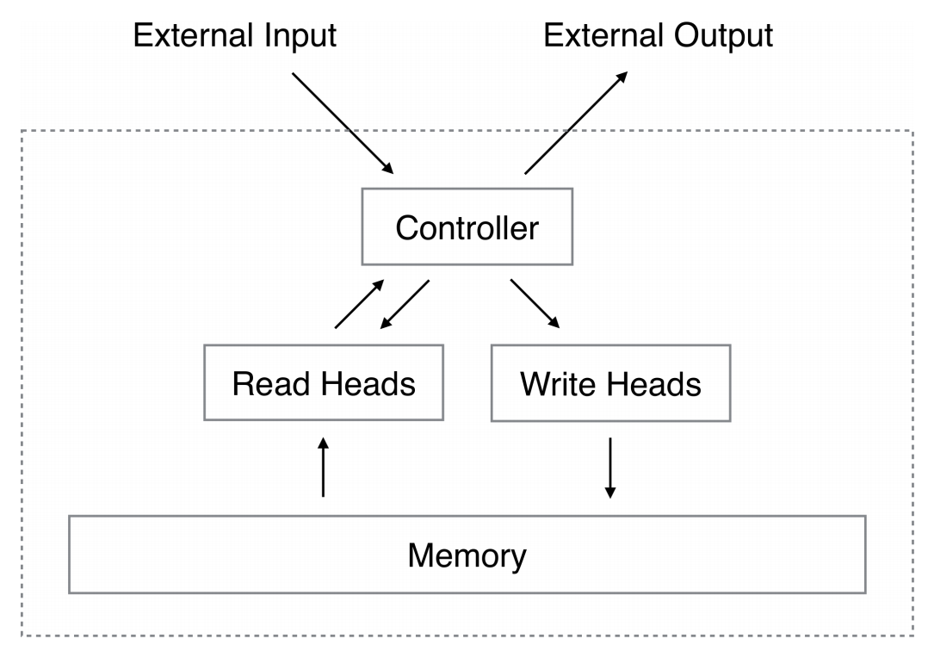
Neural Turing Machine- Application

Neural Turing Machine (NTM) – Applications
- Copying Task
  - NTM can learn to copy arbitrary sequences of data.
  - It stores the input in memory and reproduces the same sequence during output.
  - Useful for memory-based sequence learning.
- Sorting Task
  - NTM can sort sequences of numbers or vectors in a specific order.
  - Demonstrates its ability to manipulate structured data through memory.
- Associative Recall
  - NTM learns to recall items associated with a key.
  - It mimics associative memory – like finding a name from a face or vice versa.
- Question Answering
  - In tasks requiring memory over long contexts, NTM helps store and retrieve information to answer questions.
  - Useful in AI systems for document-based or conversational question answering.
- Language Modeling
  - NTM enhances traditional RNNs for modeling long-term dependencies in language sequences.
  - Helps in tasks like machine translation, text generation, and speech recognition.
- Algorithm Learning
  - NTM can learn and generalize simple algorithms like copy, repeat, and sort.
  - Acts as a trainable computer that can mimic algorithmic logic.
- Program Execution Simulation
  - Useful in interpreting and simulating the execution of basic computer programs.
  - Helps in neural programming research.
- Reinforcement Learning
  - NTMs can be used in agents that need to remember and use past states or actions to perform better in environments.
  - Suitable for complex decision-making scenarios.
- Graph-Based Reasoning
  - With structured memory, NTMs can traverse and reason over graphs.
  - Applicable in knowledge graphs and relationship inference.
- Few-Shot Learning
- NTM can learn tasks from very few examples by rapidly storing new patterns in external memory.
- Helps in scenarios with limited training data.

